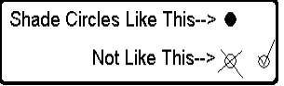
<ENTER COURSE NAME

<Enter Course Instructor Name >
Please complete and return following this session.
- Before this session, what was your level of understanding on the topic presented?
 | No understanding  1 | 2 | 3 | 4 | Complete understanding  5
Before | O | O | O | O | O
- After this session, what is your level of understanding on the topic presented?
 | No understanding  1 | 2 | 3 | 4 | Complete understanding  5
After | O | O | O | O | O
- Rate the instructor on presenting information and answering questions.
 | Poor  1 | 2 | 3 | 4 | Excellent  5
 | O | O | O | O | O
- The technical level of this session was…
 |  | Too basic  1 | 2 | Just right  3 | 4 | Too technical  5
 |  | O | O | O | O | O
- Do you have any comments or suggestions about the topic or instructor that would help improve this session?

